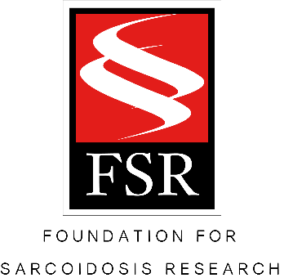

Kick in to Stop Sarcoidosis: More than a walk, it’s a movement
April 17, 2017

[enter location] – The Foundation for Sarcoidosis Research holds an annual run/walk event, the KISS 5K. KISS stands for Kick in to Stop Sarcoidosis. The nonprofit organization plans the event for April, which is Sarcoidosis Awareness Month. This year’s event will be held in Nashville, TN. However, each year, FSR supports a growing number of independent Team K.I.S.S. walks organized across the country and around the world. One of those walks will be hosted here, in [enter town/city name]!

All proceeds from the 5K in Nashville and the independent walks goes towards funding research, education, and advocacy efforts to stop this terrible disease. The walk will be on April 22, 10 am, at [enter exact location.] [Enter any extra details about your event i.e. theme, gathering before or afterwards, etc.] Contact [your name] at [your desired contact info, at least email or phone number]. Invite all your family and friends to come join us to raise awareness for this great cause!

Registration is available online as well as on the day of the event. Go to www.stopsarcoidosis.org [enter your exact event page URL] to sign up today, and don’t forget to wear your purple this Saturday!

About Sarcoidosis

Sarcoidosis (SAR-COY-DOE-SIS) is a potentially fatal inflammatory disease that can appear in almost any organ in the body. Although the lungs and lymph nodes are affected in more than 90% of patients, the disease often attacks the heart, eyes, central nervous system, liver and kidneys. There is currently no known cause, no known cure, and very few treatment options.

About the Foundation for Sarcoidosis Research

The Foundation for Sarcoidosis Research (FSR) is the nation’s leading nonprofit organization dedicated to finding a cure for this terrible disease and improving care for sarcoidosis patients. Since it’s establishment in 2000, FSR has provided over $3 million in funding for domestic and international sarcoidosis-specific research and has worked diligently to provide resources to thousands.

###

Media Contact

Amy Donatell, Foundation for Sarcoidosis Research
1820 W Webster Ave. Ste. 304
Office: (312) 341-0500
Amy@stopsarcoidosis.org

