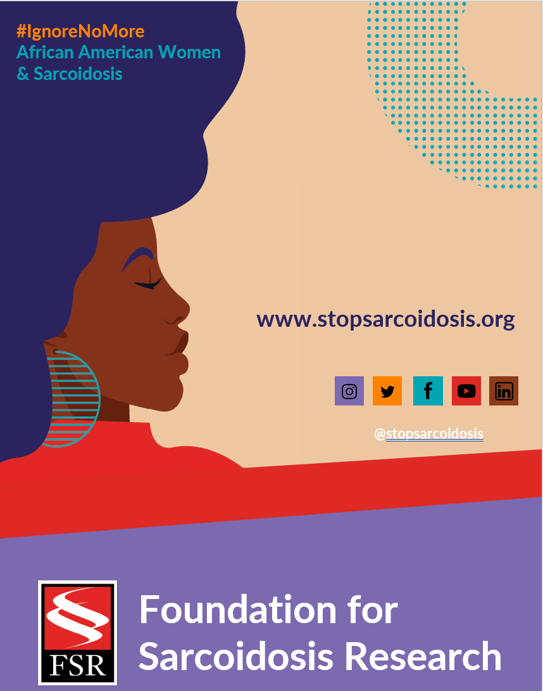
Suggested Hashtags
General Campaign: #IgnoreNoMore #Sarcoidosis #StopSarcoidosis #ChronicIllness #ChronicIllnessSupport #SarcoidosisWarrior #sarcwarrior #BlackHealth #BlackWomensHealth #WomensHealth #raredisease #SpoonieLife #HealthDisparaties #AskEngageConnect

Black History Month: #BlackHistoryMonth #BlackWomenLead #MadeInColor #ListenToBlackWomen #BlackHealthMatters #BlackIsBeautiful

Heart Month: #HeartMonth #CardiacSarcoidosis #GoRedForWomen #WearRedDay #HeartHealth #HeartHealthMonth

FEBRUARY | WEEK 2
Date | Image | Copy
Monday, 2/7 | 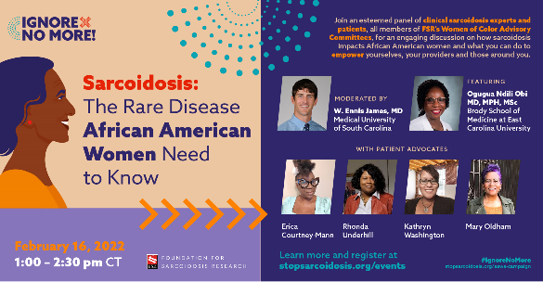 | Join @stopsarcoidosis 2/16 for an engaging discussion on #sarcoidosis, how it impacts African American women, and what can be done to improve outcomes. Register here: https://bit.ly/3r5DglX #IgnoreNoMore #blackwomenshealth #raredisease #PatientEmpowerment
Wednesday, 2/9 | 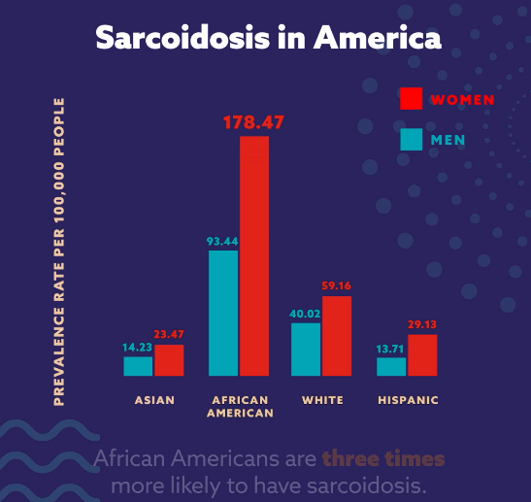  (ANIMATED GRAPHIC VIDEO) | African American women are 3x more likely to have #sarcoidosis than other groups & have higher hospitalization rates. Ask about the symptoms. Learn more: https://bit.ly/3DG6FXc #IgnoreNoMore #blackwomenshealth #healthdisparity  Tag @stopsarcoidosis
Friday, 2/11 | 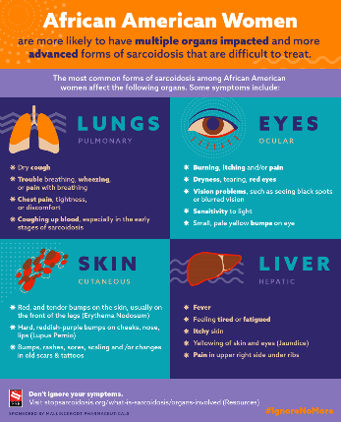 | African American women have more severe forms of sarcoidosis. Learn the signs and ask your physician about your symptoms. Learn more: https://bit.ly/3DG6FXc #IgnoreNoMore #blackhealthmatters #raredisease #sarcoidosis

