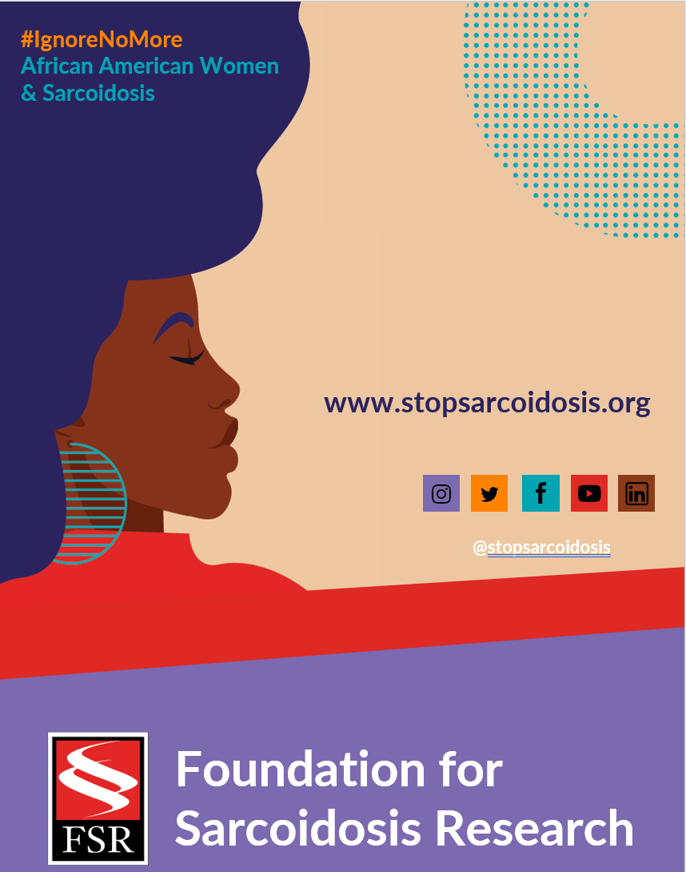
Suggested Hashtags
General Campaign: #IgnoreNoMore #Sarcoidosis #StopSarcoidosis #ChronicIllness #ChronicIllnessSupport #SarcoidosisWarrior #sarcwarrior #BlackHealth #BlackWomensHealth #WomensHealth #raredisease #SpoonieLife #HealthDisparaties #AskEngageConnect

Black History Month: #BlackHistoryMonth #BlackWomenLead #MadeInColor #ListenToBlackWomen #BlackHealthMatters #BlackIsBeautiful

Heart Month: #HeartMonth #CardiacSarcoidosis #GoRedForWomen #WearRedDay #HeartHealth #HeartHealthMonth

FEBRUARY | WEEK 3
Date | Image | Copy
Monday, 2/14 | 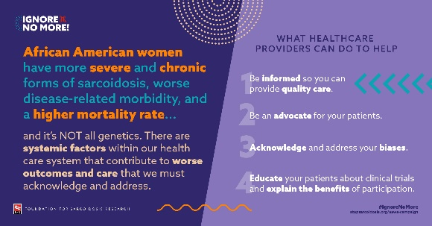 | Healthcare providers can help improve health disparities among African American women through understanding, education, and advocacy. Learn more: https://bit.ly/3rYsdue #IgnoreNoMore #blackhealthmatters #raredisease #healthequity #medtwitter
Friday, 2/18 | 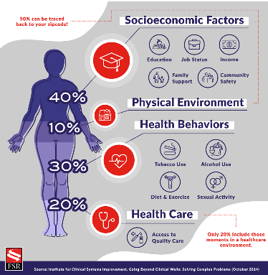 | Your zip code is the biggest determinant of your health outcomes. I am proud to support @stopsarcoidosis by raising awareness of health disparities. Learn more: Link to campaign #IgnoreNoMore #SocialDeterminantsofHealth #DEI #sarcoidosis

