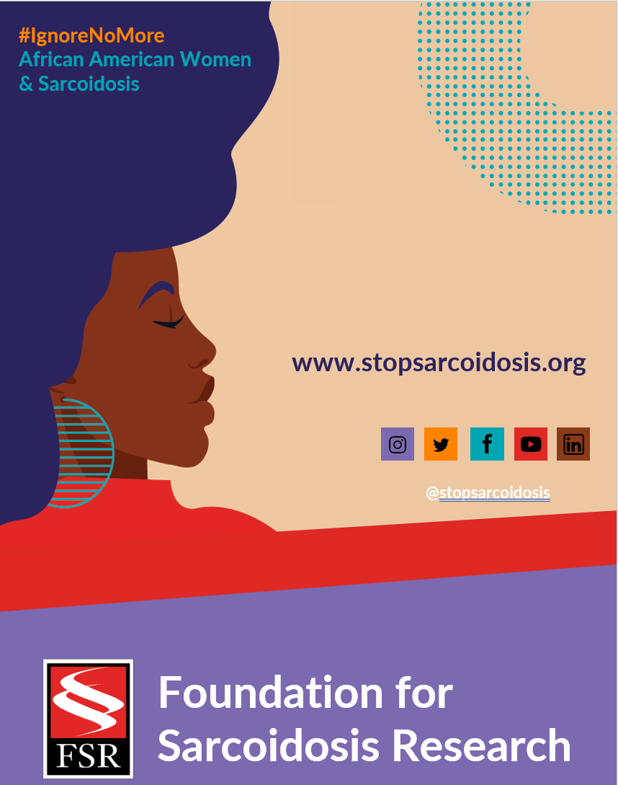
Suggested Hashtags
General Campaign: #IgnoreNoMore #Sarcoidosis #StopSarcoidosis #ChronicIllness #ChronicIllnessSupport #SarcoidosisWarrior #sarcwarrior #BlackHealth #BlackWomensHealth #WomensHealth #raredisease #SpoonieLife #HealthDisparaties #AskEngageConnect

Black History Month: #BlackHistoryMonth #BlackWomenLead #MadeInColor #ListenToBlackWomen #BlackHealthMatters #BlackIsBeautiful

Heart Month: #HeartMonth #CardiacSarcoidosis #GoRedForWomen #WearRedDay #HeartHealth #HeartHealthMonth

MARCH | WEEK 5
Date | Image | Copy
Tuesday, 3/1 | 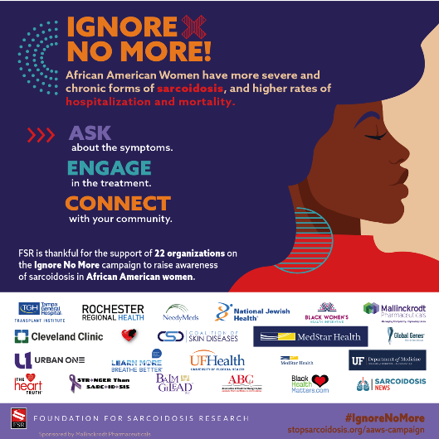 | I am proud to support @stopsarcoidosis to raise awareness of African American women and sarcoidosis. Keep the conversation going and learn more https://bit.ly/3DG6FXc #IgnoreNoMore #blackwomenshealth #raredisease #sarcoidosis

