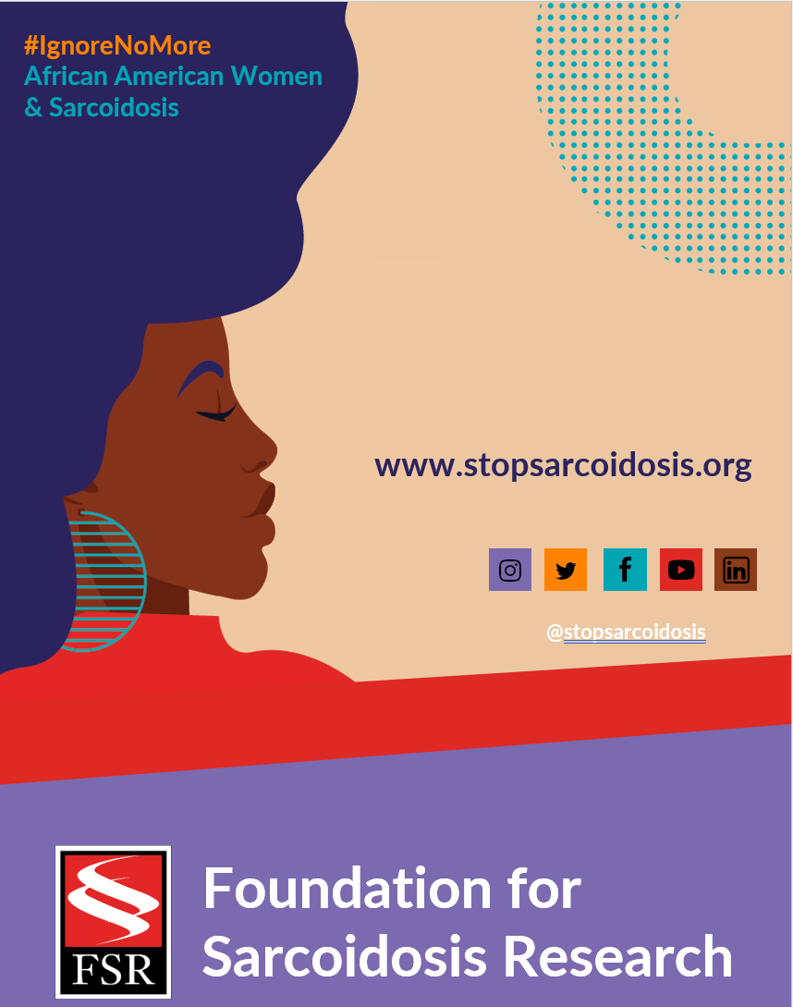

FEBRUARY | WEEK 3
Date | Image | Copy
Monday, 2/14 | 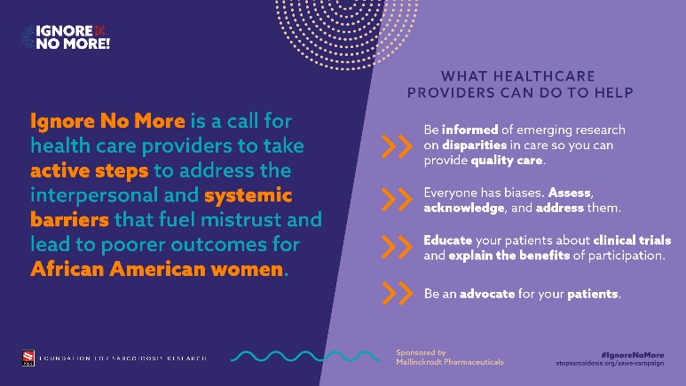 | Healthcare providers can help improve health disparities among African American women through understanding, education, and advocacy. Learn more: https://bit.ly/3rYsdue #IgnoreNoMore #blackhealthmatters #raredisease #healthequity #medtwitter
Friday, 2/18 | 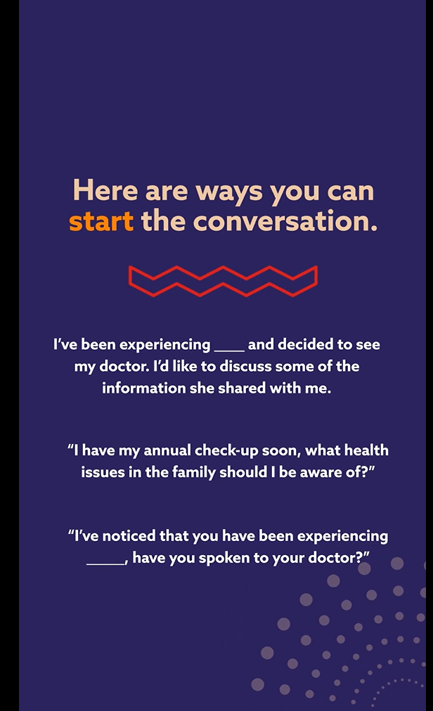  ANIMATED VIDEO LINK | It is crucial to discuss health matters with your family. Start the conversation with these tips. Learn more: https://bit.ly/3rYsdue #IgnoreNoMore #raredisease #sarcoidosis

