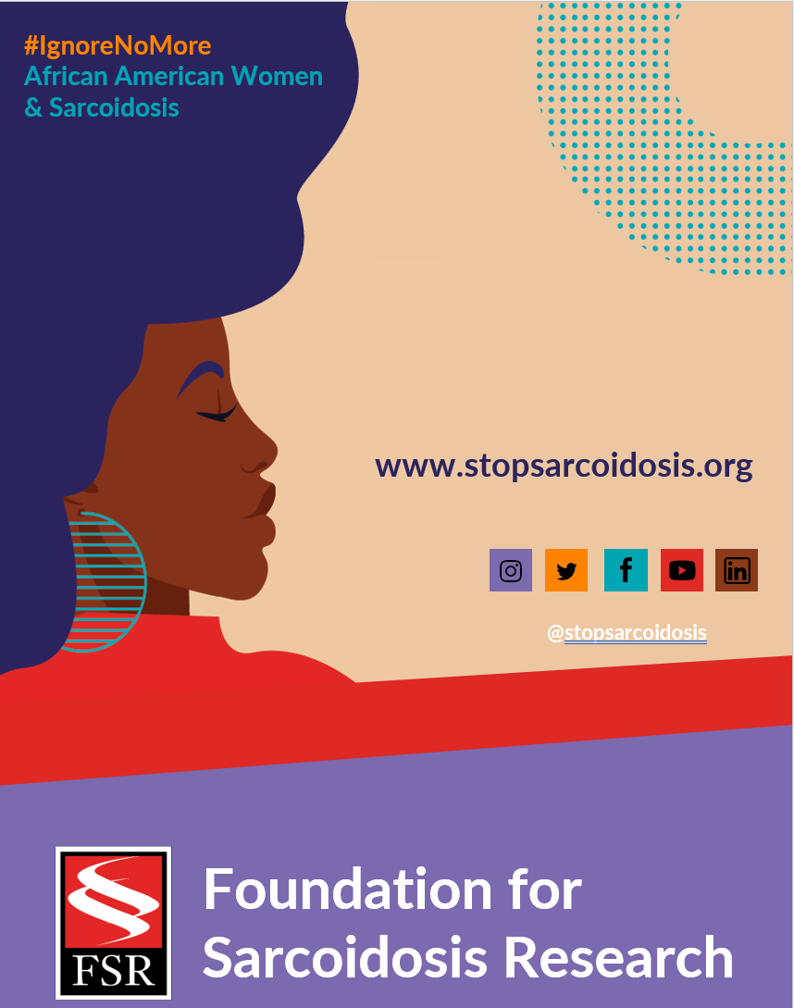

FEBRUARY | WEEK 4
Date | Image | Copy
Tuesday, 2/22 | 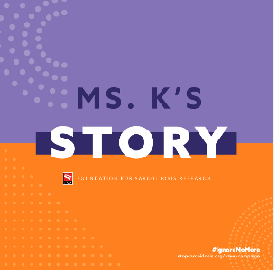 | Communication between providers and patients is key to developing a treatment plan that works. Learn more: https://bit.ly/3DG6FXc #IgnoreNoMore #raredisease #sarcoidosis #chronicillness
Thursday, 2/24 | 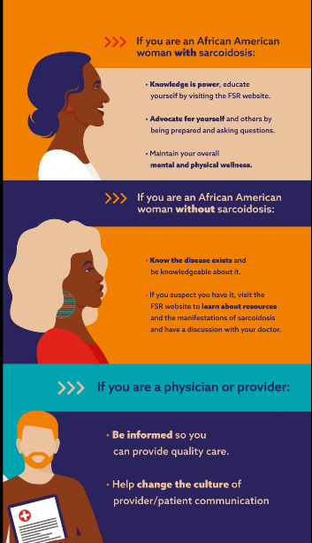  (ANIMATED GRAPHIC VIDEO LINK) | We’re dedicated to raising awareness and understanding of African American women’s high prevalence in sarcoidosis. Learn more: https://bit.ly/3DG6FXc #IgnoreNoMore #raredisease #blackwomenshealth #sarcoidosis

