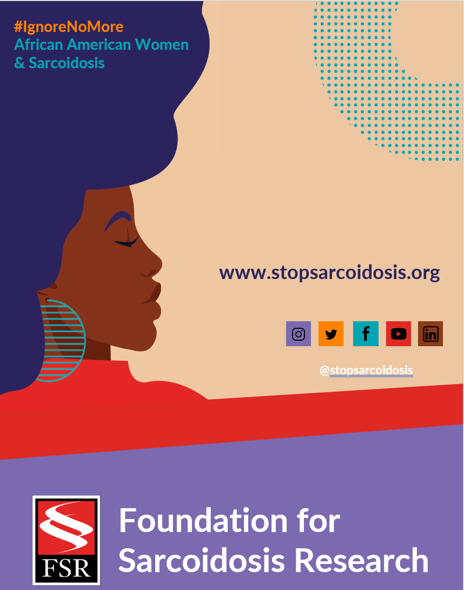

JANUARY WEEK 1
Date | Image |  | Copy
Monday, 1/31 | 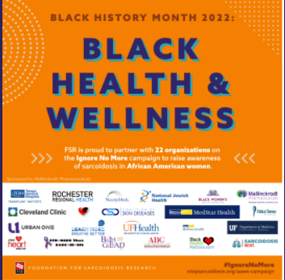 |  | (YOUR COMPANY NAME) celebrates #BlackHistoryMonth this February by centering Black health initiatives. We are proud to partner with @stopsarcoidosis to raise awareness in the upcoming #IgnoreNoMore: African American Women & #Sarcoidosis Campaign. Learn more https://bit.ly/3DG6FXc
FEBRUARY
Date |  | Image |  | Copy
Tuesday, 2/1 |  | 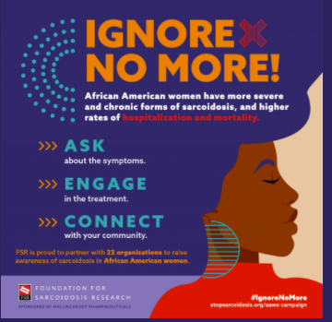 |  | (YOUR COMPANY NAME) is proud to partner with @stopsarcoidosis to raise awareness about disparities in healthcare for African American women . Learn more https://bit.ly/3DG6FXc #IgnoreNoMore #BlackHistoryMonth #blackwomenshealth #raredisease #sarcoidosis #DEI
Friday, 2/4 |  | (LINK TO VIDEO) |  | Watch as actress Jeryl Prescott discusses her journey with cardiac sarcoidosis as part of the @stopsarcoidosis #IgnoreNoMore campaign (video link) #WearRedDay #WearRedDay2022 #sarcoidosis #blackwomenshealth  Note: Link to YouTube video here.

