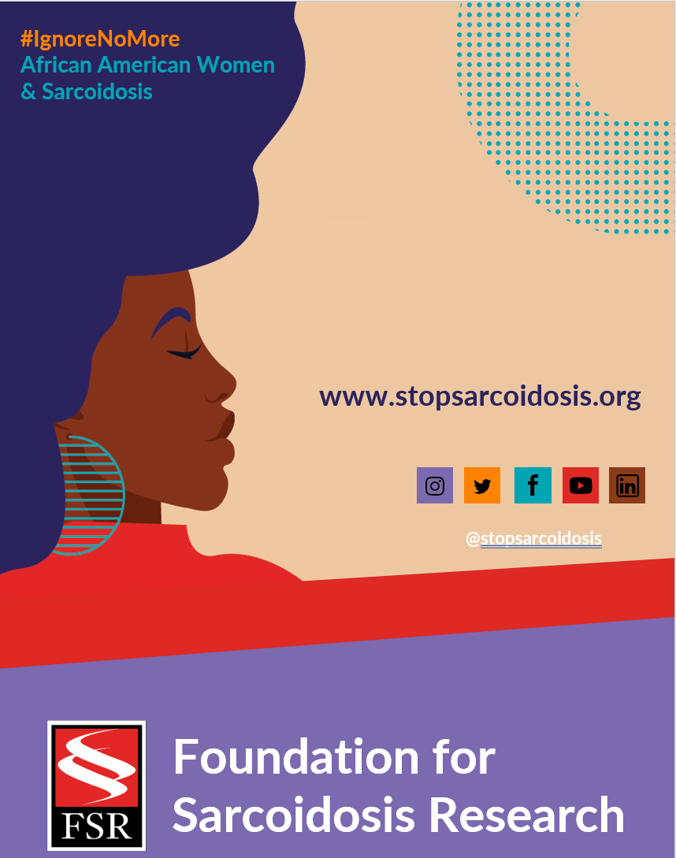

FEBRUARY | WEEK 2
Date | Image | Copy
Monday, 2/7 | 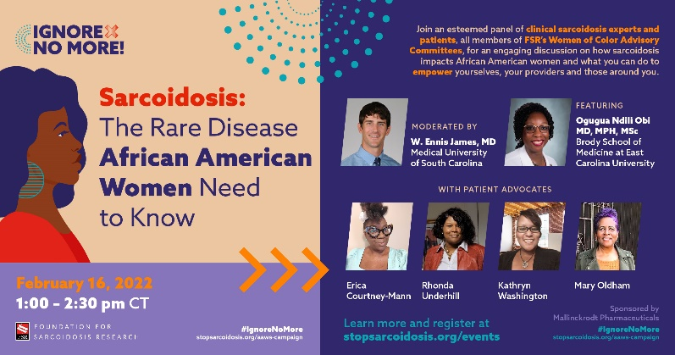 | Join @stopsarcoidosis 2/16 for an engaging discussion on #sarcoidosis, how it impacts African American women, and what can be done to improve outcomes. Register here: https://bit.ly/3r5DglX #IgnoreNoMore #blackwomenshealth #raredisease #PatientEmpowerment
7Wednesday, 2/9 | 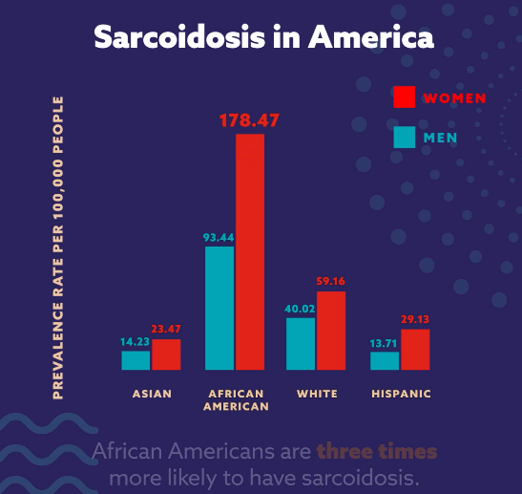  (ANIMATED GRAPHIC VIDEO LINK) | African American women are 3x more likely to have #sarcoidosis than other groups. Learn more: https://bit.ly/3DG6FXc #IgnoreNoMore #blackwomenshealth #healthdisparity #sarcoidosisawareness
Friday, 2/11 | 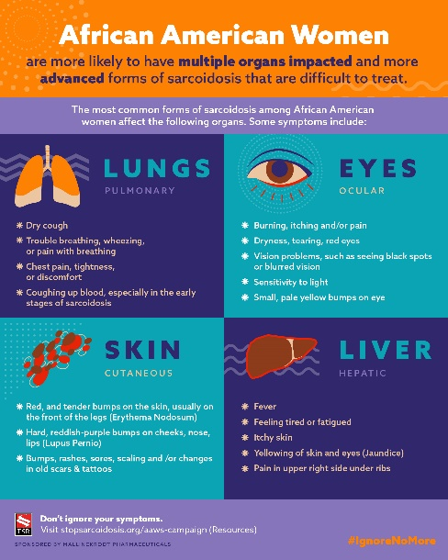 | African American women have more severe forms of sarcoidosis. Learn the signs and ask your physician about your symptoms. Learn more: https://bit.ly/3DG6FXc #IgnoreNoMore #blackhealthmatters #raredisease #sarcoidosis

