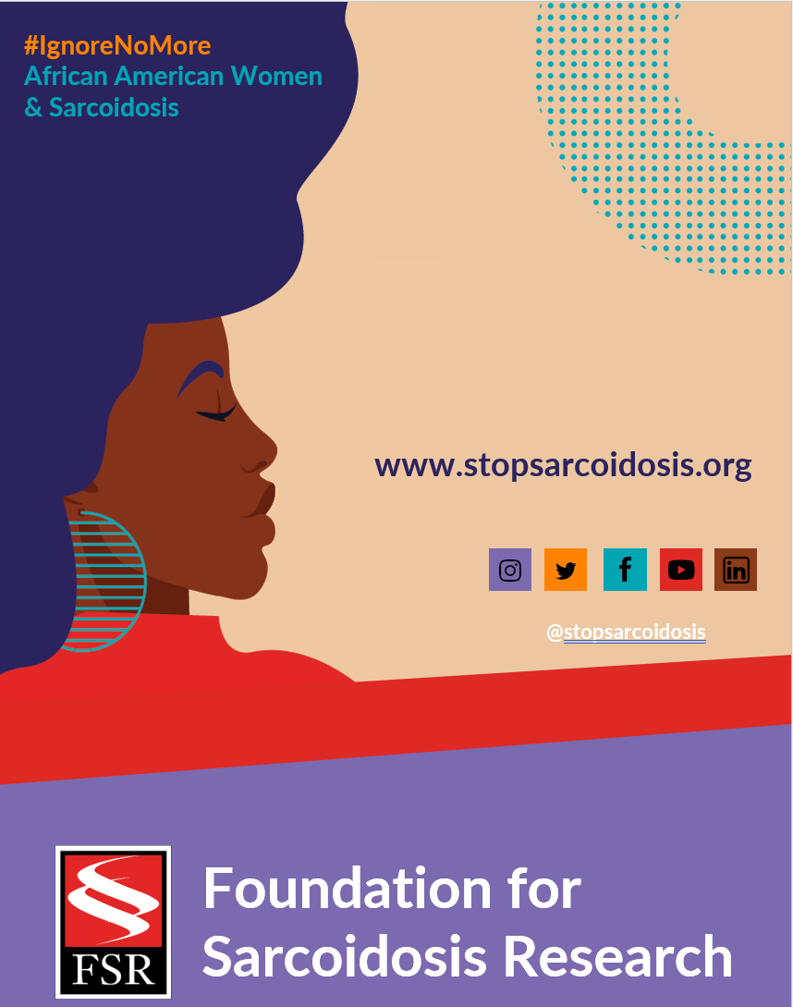

MARCH | WEEK 5
Date | Image | Copy
Tuesday, 3/1 | 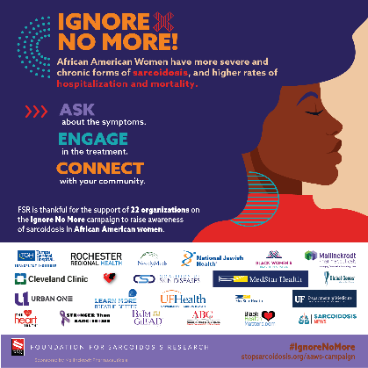 | (YOUR COMPANY NAME) is proud to have partnered with @stopsarcoidosis to raise awareness of African American women and sarcoidosis. Keep the conversation going and learn more https://bit.ly/3DG6FXc #IgnoreNoMore #blackwomenshealth #raredisease #sarcoidosis

