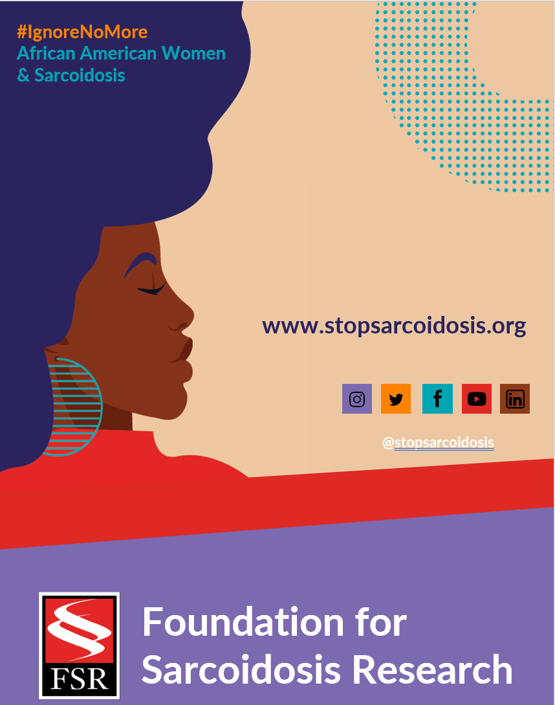
Suggested Hashtags
General Campaign: #IgnoreNoMore #Sarcoidosis #StopSarcoidosis #ChronicIllness #ChronicIllnessSupport #SarcoidosisWarrior #sarcwarrior #BlackHealth #BlackWomensHealth #WomensHealth #raredisease #SpoonieLife #HealthDisparaties #AskEngageConnect

Black History Month: #BlackHistoryMonth #BlackGirlMagic #BlackWomenLead #MadeInColor #ListenToBlackWomen #BlackHealthMatters #BlackIsBeautiful

Heart Month: #HeartMonth #CardiacSarcoidosis #GoRedForWomen #WearRedDay #HeartHealth #HeartHealthMonth

JANUARY WEEK 1
Date | Image |  |  | Copy
Monday, 1/31 | 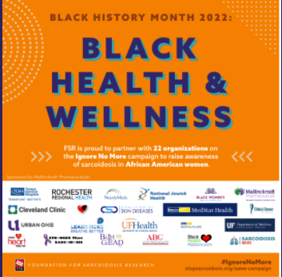 |  |  | I am proud to celebrate #BlackHistoryMonth this February by centering Black health initiatives like the upcoming @stopsarcoidosis #IgnoreNoMore: African American Women & #Sarcoidosis Campaign. Learn more https://bit.ly/3DG6FXc  #sarcoidosis #blackhistorymonth  #blackwomenshealth
FEBRUARY
Date |  | Image | Copy
Tuesday, 2/1 |  | 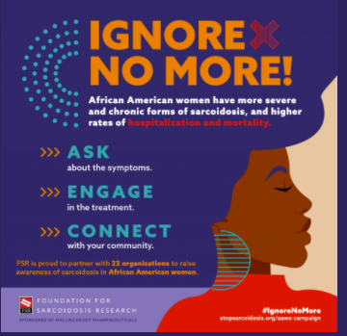 | I am proud to serve as an advocate for @stopsarcoidosis to raise awareness about disparities in healthcare for African American women. Learn more https://bit.ly/3DG6FXc #IgnoreNoMore #BlackHistoryMonth #blackwomenshealth #raredisease #sarcoidoosis #DEI #blackgirlmagic
Friday, 2/4 |  | (LINK TO VIDEO) | Watch as actress Jeryl Prescott Gallien discusses her journey with cardiac sarcoidosis as part of the @stopsarcoidosis #IgnoreNoMore campaign (video link) #WearRedDay #WearRedDay2022 #sarcoidosis #blackwomenshealth  #blackgirlmagic  #blackhistorymonth  #heartmonth  Note: Video link will be shared by FSR on Friday morning to post with copy.

