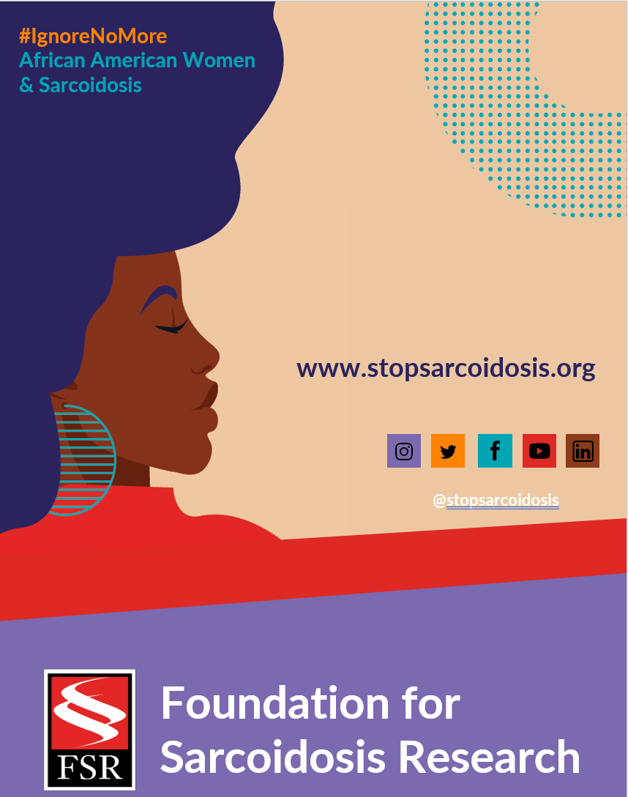
Suggested Hashtags
General Campaign: #IgnoreNoMore #Sarcoidosis #StopSarcoidosis #ChronicIllness #ChronicIllnessSupport #SarcoidosisWarrior #sarcwarrior #BlackHealth #BlackWomensHealth #WomensHealth #raredisease #SpoonieLife #HealthDisparaties #AskEngageConnect

Black History Month: #BlackHistoryMonth #BlackGirlMagic #BlackWomenLead #MadeInColor #ListenToBlackWomen #BlackHealthMatters #BlackIsBeautiful

Heart Month: #HeartMonth #CardiacSarcoidosis #GoRedForWomen #WearRedDay #HeartHealth #HeartHealthMonth

FEBRUARY | WEEK 4
Date | Image | Copy
Tuesday, 2/22 | 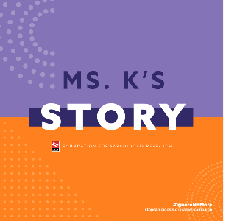 | Communication between providers and patients is key to developing a treatment plan that works. I know it was for me. Learn more: https://bit.ly/3DG6FXc #IgnoreNoMore #raredisease #sarcoidosis #chronicillness
Thursday, 2/24 | 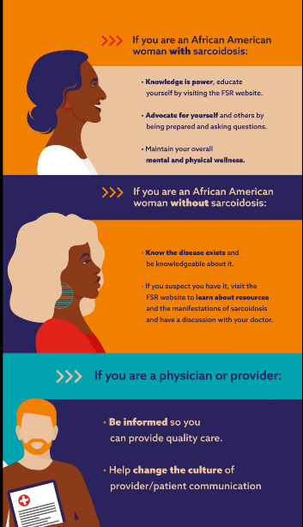  (ANIMATED GRAPHIC VIDEO) | We’re dedicated to raising awareness and understanding of African American women’s high prevalence in sarcoidosis. Be part of the solution. Learn more: https://bit.ly/3DG6FXc #IgnoreNoMore #raredisease #blackwomenshealth #sarcoidosis

