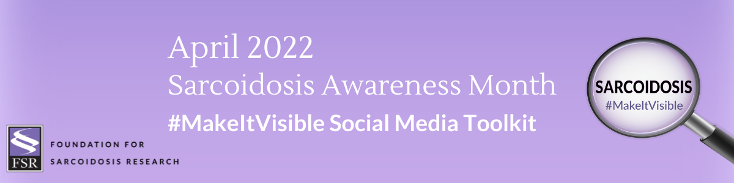

April is Sarcoidosis Awareness Month
Please join us to help raise awareness and make sarcoidosis visible by creating a better understanding of how the disease impacts you, those you love, and the community each and every day.

This toolkit offers recommended posts for Facebook, Twitter, Instagram and LinkedIn. We also provide suggested hashtags and information for tagging FSR on various platforms. Raise awareness, share your personal story and use these tools on your social platforms as you see fit.

Click here to download accompanying graphics.

Help us spread the word!

Tag FSR in your posts so we can share/amplify!

Facebook: @StopSarcoidosis Twitter: @StopSarcoidosis Instagram: @StopSarcoidosis
LinkedIn: @Foundation for Sarcoidosis Research

Hashtags:

#MakeItVisible
#WhatIsSarcodosis
#SarcoidosisAwareness
#Sarcoidosis

Tips:

- Personalize posts or copy with your own story and messaging.
- Encourage your social media followers to get involved and spread the word as well! Tag friends and challenge them to share.
- Repost FSR content and share multiple times throughout the month!

Suggested Social Media Posts
April is Sarcoidosis Awareness Month! There are several ways to get involved throughout the entire month and make sarcoidosis visible! Learn more at stopsarcoidosis.org/awareness-2022! #Sarcoidosis #MakeItVisible #SarcoidosisAwareness #WhatIsSarcoidosis

The lungs are affected in more than 90% of patients with sarcoidosis. Common symptoms
of pulmonary sarcoidosis are a cough that does not go away, shortness of breath, and chest pain. Learn more at stopsarcoidosis.org/awareness-2022! #Sarcoidosis #MakeItVisible #SarcoidosisAwareness #WhatIsSarcoidosis

Did you know that approximately 175,000 people are living with sarcoidosis in the United States? Join me this April to raise awareness and make a difference! Visit stopsarcoidosis.org/awareness-2022! #Sarcoidosis #MakeItVisible #SarcoidosisAwareness #WhatIsSarcoidosis

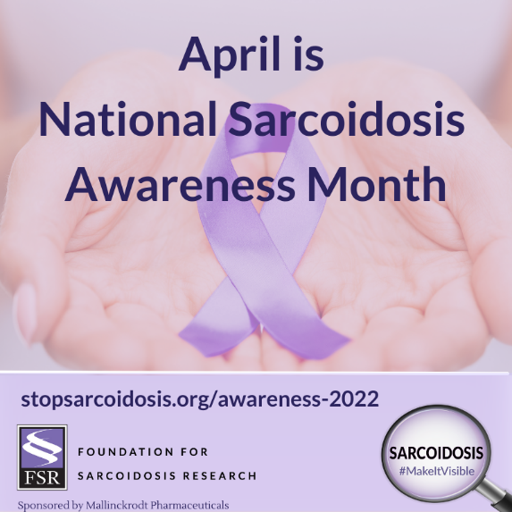

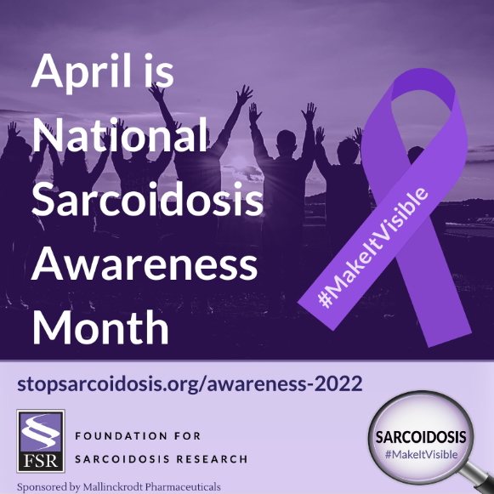

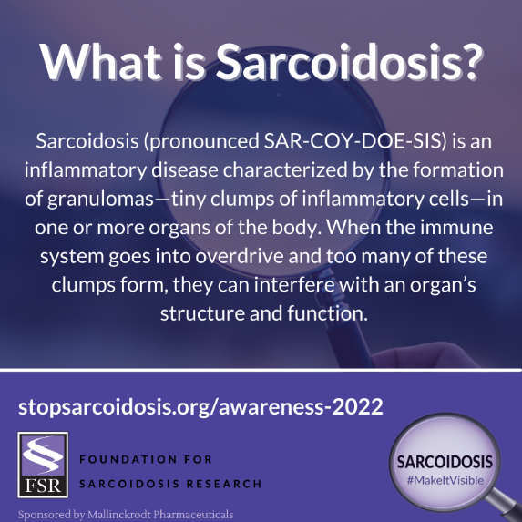
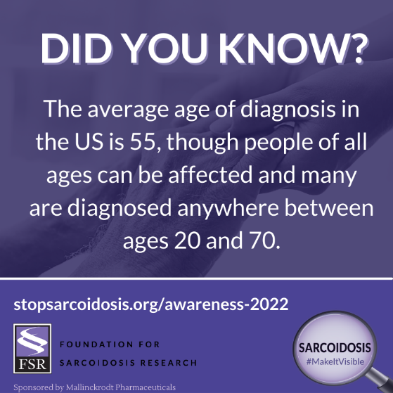
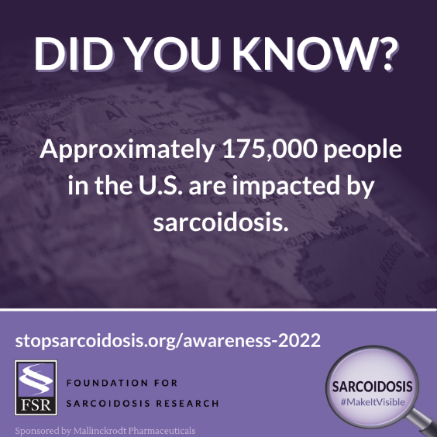

Steps for Sarc Virtual Endurance Challenge: April 1 – 30

Facebook, Instagram, LinkedIn:

To raise awareness and unite the community during April’s Sarcoidosis Awareness Month, FSR will be hosting a month-long virtual endurance and awareness challenge! Join me as I walk, run, step, or hike to reach 61,250,000 MILLION steps as a community! Learn more at stopsarcoidosis.org/awareness-2022! #Sarcoidosis #MakeItVisible #SarcoidosisAwareness #WhatIsSarcoidosis

Shortened for Twitter:

To raise awareness and unite the community during April’s Sarcoidosis Awareness Month, FSR will be hosting a month-long virtual endurance and awareness challenge! Learn more at stopsarcoidosis.org/awareness-2022 and join us! #Sarcoidosis #MakeItVisible #SarcoidosisAwareness #WhatIsSarcoidosis

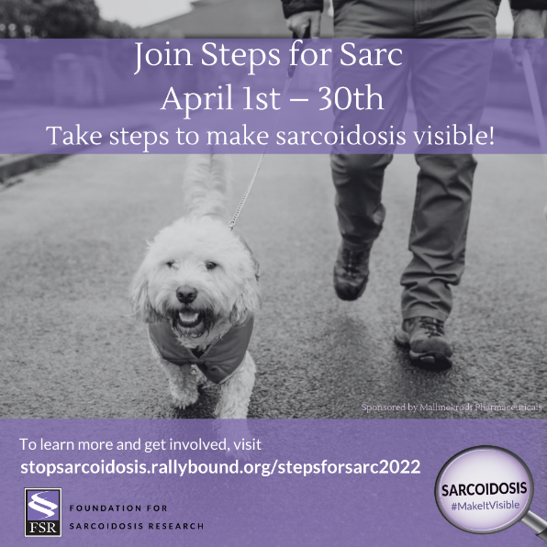

For Facebook, LinkedIn, and Instagram:

April is Sarcoidosis Awareness Month! Join us in the Steps for Sarc Virtual Endurance Challenge, a physical distance and awareness effort! Together we can walk, run, step, or hike to reach 61,250,000 MILLION steps collectively while working to raise a total of $61,250 for FSR’s research programs. Visit stopsarcoidosis.org/awareness-2022 for complete details! #Sarcoidosis #MakeItVisible #SarcoidosisAwareness #WhatIsSarcoidosis

For Twitter:

April is Sarcoidosis Awareness Month! Join us in the Steps for Sarc Virtual Endurance Challenge, a fundraising and awareness effort! Visit stopsarcoidosis.org/awareness-2022 for complete details! #Sarcoidosis #MakeItVisible #SarcoidosisAwareness #WhatIsSarcoidosis

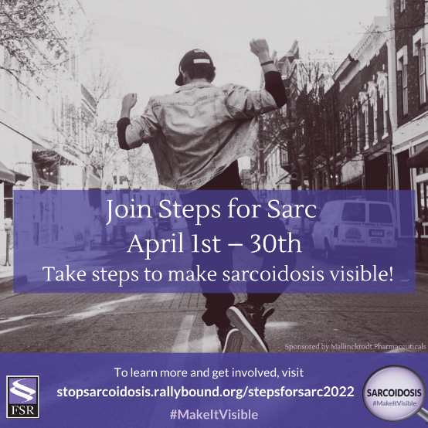

Share Your Photos

World Sarcoidosis Day: April 13

World Sarcoidosis Day is on April 13th! On this day, we will be wearing purple alongside @stopsarcoidosis to show our support for all those who are fighting this disease. Join us! Take a selfie wearing your favorite purple shirt and share the photo on social media for your friends, family, and network to see! Learn more at stopsarcoidosis.org/awareness-2022! #Sarcoidosis #MakeItVisible #SarcoidosisAwareness #WhatIsSarcoidosis #WorldSarcDay

