April is Sarcoidosis Awareness Month

Please join us to help raise awareness and create a better understanding of how sarcoidosis impacts you, those you love, and the community each and every day.

This toolkit offers recommended posts for Facebook, Twitter, Instagram and LinkedIn. We also provide suggested hashtags and information for tagging FSR on various platforms. Raise awareness, share your personal story and use these tools on your social platforms as you see fit.

Click here to download accompanying graphics.

Help us spread the word!
Tag FSR in your posts so we can share/amplify!

Facebook: @StopSarcoidosis
Twitter: @StopSarcoidosis
Instagram: @StopSarcoidosis
LinkedIn: @Foundation for Sarcoidosis Research

Hashtags:

#SarcoidosisAwarenessMonth
#Sarcoidosis
#raredisease

Tips:

Personalize posts or copy and paste the suggested text we’ve provided in this document.
Encourage your social media followers to get involved and spread the word as well!

Suggested Social Media Posts

April is Sarcoidosis Awareness Month! There are several ways to get involved throughout the entire month! Learn more at https://www.sarcoidosis.org/awareness! #Sarcoidosis #SarcoidosisAwarenessMonth

The lungs are affected in more than 90% of patients with sarcoidosis. Common symptoms of pulmonary sarcoidosis are a cough that does not go away, shortness of breath, and chest pain. Learn more at https://www.sarcoidosis.org/awareness! #Sarcoidosis #SarcoidosisAwarenessMonth

Did you know that approximately 200,000 people are living with sarcoidosis in the United States? Join me this April to raise awareness and make a difference! Visit stopsarcoidosis.org/awareness to learn more. #Sarcoidosis #SarcoidosisAwarenessMonth
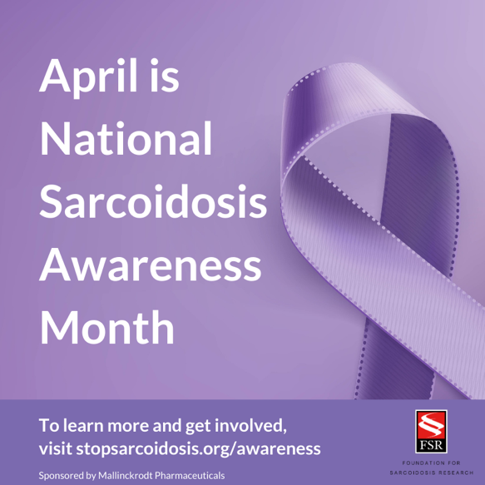

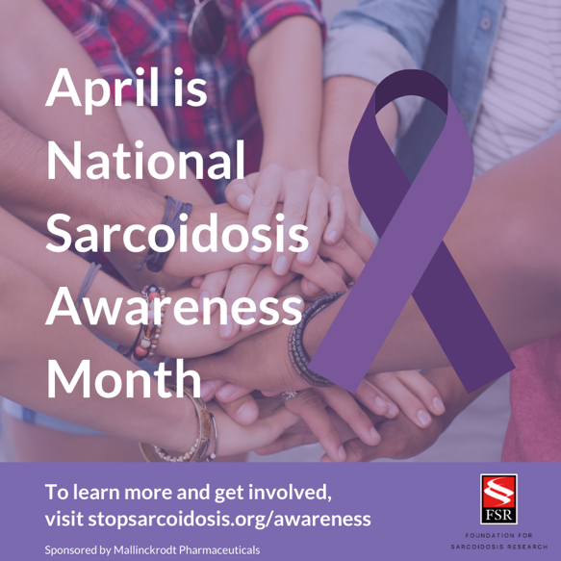
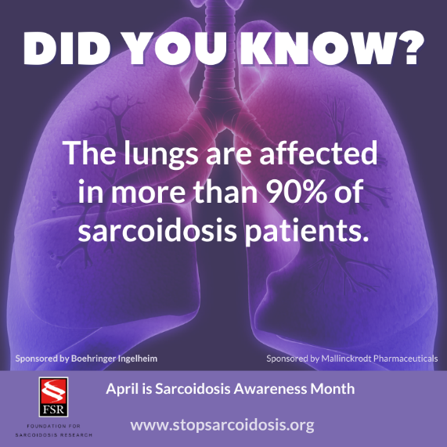

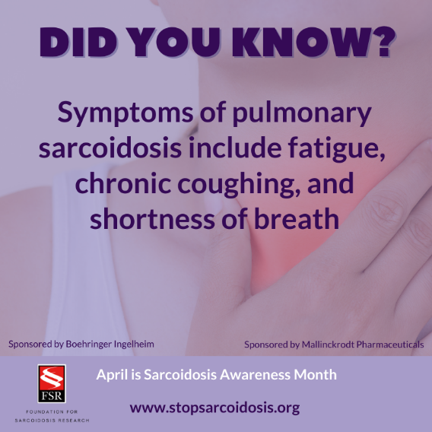

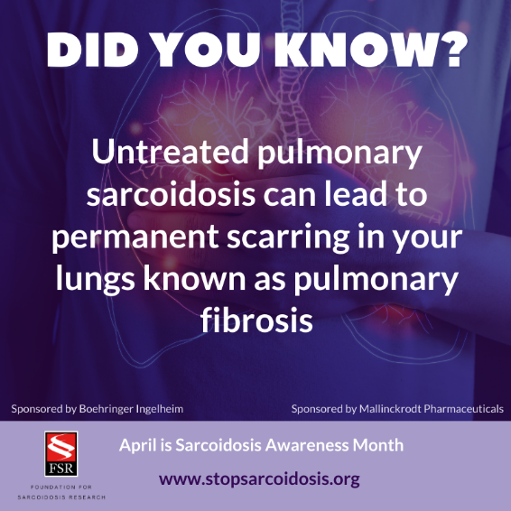

Steps for Sarc Virtual Endurance Challenge: April 1 – 30

For Facebook, LinkedIn and Instagram:

To raise awareness and unite the community during April’s Sarcoidosis Awareness Month, FSR will be hosting a month-long virtual endurance and fundraising challenge! Join us as we walk, run, step, or hike to reach 9 MILLION steps collectively or complete the equivalent of 4,500 miles together! Learn more at stopsarcoidosis.org/awareness! #Sarcoidosis #SarcoidosisAwarenessMonth

Shortened for Twitter:

This April I’m raising awareness about sarcoidosis by joining the #StepsforSarc Virtual Endurance Challenge! Learn more at https://www.sarcoidosis.org/awareness.
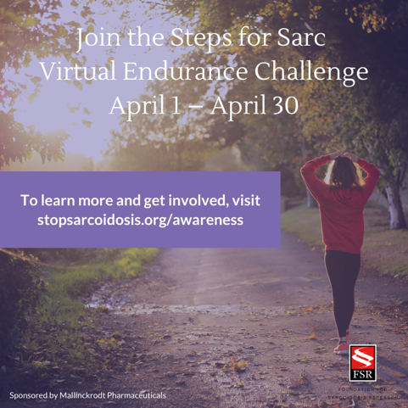

For Facebook, LinkedIn and Instagram:

April is Sarcoidosis Awareness Month! Join me in the Steps for Sarc Virtual Endurance Challenge, a physical distance and fundraising effort! Together we can walk, run, step, or hike to reach 9 MILLION steps collectively while working to raise a total of $25,000 for FSR’s research programs. Visit stopsarcoidosis.org/awareness for complete details! #Sarcoidosis #SarcoidosisAwarenessMonth

For Twitter:

Now is the time to take action! Join me in raising awareness about sarcoidosis by participating the #StepsforSarc Virtual Endurance Challenge! https://www.sarcoidosis.org/awareness #Sarcoidosis #SarcoidosisAwarenessMonth

Share Your Photos

World Sarcoidosis Day: April 13

World Sarcoidosis Day is on April 13th! On this day, we will be wearing purple alongside the Foundation for Sarcoidosis Research to show our support for all those who are fighting this disease. Join us! Take a selfie wearing your favorite purple shirt and share the photo on social media for your friends, family, and network to see! #WorldSarcDay #Sarcoidosis #SarcoidosisAwarenessMonth
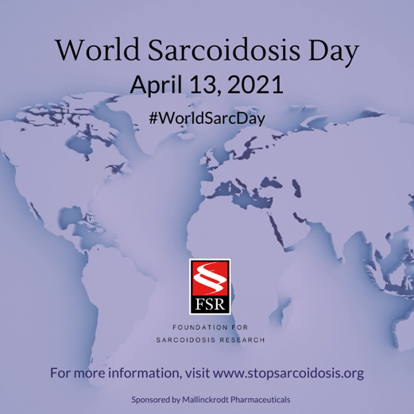

#MaskUpMondays

Show off your FSR mask every Monday throughout the month of April! Snap a few photos each week and post them to Facebook, Instagram, Twitter and LinkedIn. Don’t forget to tag FSR and use the hashtag #MaskUpMondays!

Suggested social media post:

I’m raising awareness about sarcoidosis during the month of April! To learn more visit www.stopsarcoidosis.org/awareness. #Sarcoidosis #SarcoidosisAwarenessMonth

Facebook Profile Photo Frame
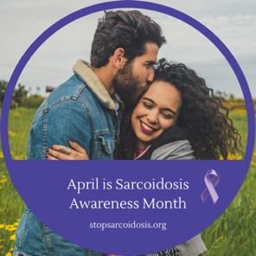
Update your Facebook profile photo with a Sarcoidosis Awareness Month frame and let your friends, family and network know that you are raising awareness during the month of April.

Take these simple steps: just sign into your Facebook account and then visit Profile Picture Frames. Search for “Sarcoidosis Awareness Month” and select the frame. Don’t forget to click “Use as Profile Picture” to save your changes!

