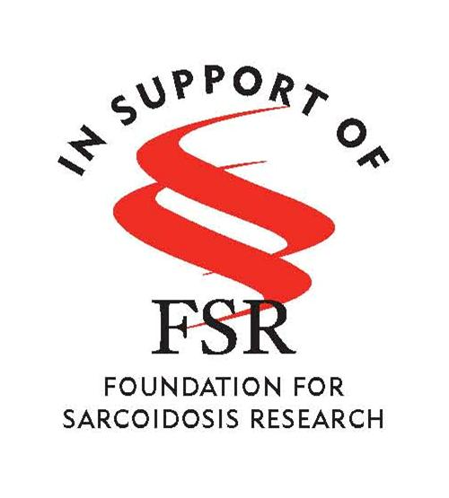
DATE
Name
Address

Dear insert name:

Please consider making a donation to the 2018 FSR Team KISS 5K Run/Walk. The event will be held on April 28th, 2018 at in Atlanta, Georgia. Funds raised by the 2018 Team KISS 5K Run/Walk will support the Foundation for Sarcoidosis Research (FSR), the nation’s leading nonprofit organization dedicated to improving care for sarcoidosis patients and to find a cure for this disease.
Sarcoidosis (pronounced SAR-COY-DOE-SIS) is a potentially fatal inflammatory disease that can appear in almost any organ in the body. People of any age, race and gender can be affected and symptoms vary from person to person. The causes of sarcoidosis are not yet known and there is no cure.
This event is important to me because …include a few sentences here about why this cause and event are important to you and what you hope it will accomplish.
Please send your donation to the Foundation for Sarcoidosis at 1820 W. Webster Avenue, Suite 304, Chicago, IL 60614. FSR is a 501c3 nonprofit organization and donations are tax deductible to the extent allowed by law.
Should you have any questions about the 2018 FSR Team KISS 5K Run/Walk, please contact me at your phone number and email address. For additional information about sarcoidosis or the work of FSR, please feel free to contact Angela Frelander, Development Manager, at 312-341-0500 or angela@stopsarcoidosis.org.

Thank you for your generosity in supporting a cause that is so important to me!

Sincerely,
Your name

